[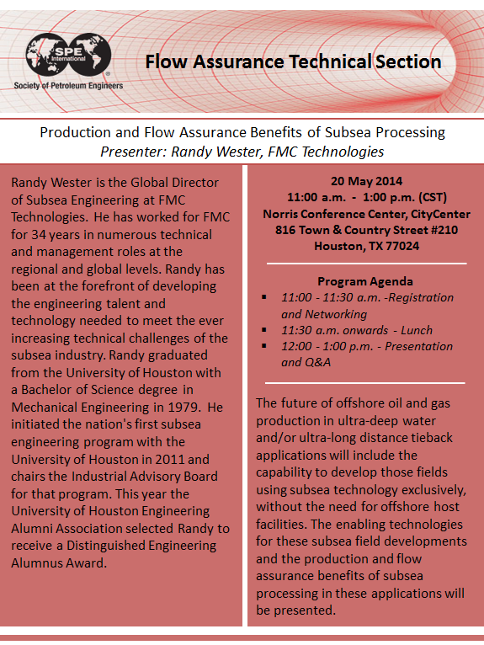](http://connect.spe.org/fts/events/eventdescription/?CalendarEventKey=39142181-97b0-4e4a-b7b2-39c4cc3bc2d1&EventTypeKey=&Home=/fts/events/internationalcalendar/)