
Society of Petroleum Engineers

Dallas • Dubai • Houston • Kuala Lumpur • London
www.spe.org

To: SPE Section Chairpersons

Reference: Society's Policy Concerning Service of Alcoholic Beverages

As a 2007-2008 SPE section chairperson you should carefully consider the Society's policy concerning the service of alcoholic beverages in connection with SPE meetings.

Legal briefings are full of reports on judgments awarded to plaintiffs and assignments of liability and accompanying damages to organizations that serve alcoholic beverages in connection with events. The law no longer looks solely to the consumer of liquor for responsibility and/or liability for his own conduct after drinking. Judicially developed consumer law and legislatively promulgated statutes in varying jurisdictions have increasingly changed the rules with regard to allocating responsibility for consequences of alcohol-impaired behavior by others. Whether by dram shop act or evolving theories of innkeeper liability, many states now extend responsibility for injuries and damages to those serving alcoholic beverages. This is the case, whether in business or even family social contexts, for "reasonably monitoring and restricting" consumption, even though the server has no way of knowing where the drinker has been, where he is going, or what he has had or will have to drink elsewhere, much less of keeping an accurate count of each drink. While there are practices that may in some cases tend to limit or restrict liability, the best "safe haven" is simply to not serve any alcoholic beverages in connection with an event sponsored by an SPE section.

The Society does not endorse or recommend dispensing alcoholic beverages in connection with SPE meetings. The Society, however, recognizes that some SPE sections follow a practice of having SPE meetings at facilities (hotel, restaurant or club) which serve alcoholic beverages. If a section officer does plan events at a facility that serves alcoholic beverages, SPE requests that the following guidelines are followed:

1. The facility at which the event is being held should sell and dispense all alcoholic beverages. SPE members should never sell drinks or dispense alcoholic beverages.

2. No charge to or payment collected from an SPE member in connection with attendance at an SPE meeting should be related to the service of alcohol.

3. If the meeting involves a cash bar, the facility should be asked to sell drink tickets as opposed to directly dispensing liquor in exchange for cash.

Society's Policy Concerning Service of Alcoholic Beverages
Page 2

4. Most facilities now have a training program for staff members to ensure the responsible service of alcoholic beverages. Inquire to confirm this.

5. A copy of the facility's liquor liability insurance policy and a statement of indemnification to the section and SPE should be obtained.

6. Section officers should encourage the practice of "designated drivers" in conjunction with SPE functions.

7. Consult legal counsel in your respective jurisdictions for more specific guidance and/or prohibitions in your area.

This is potentially a very serious issue that we ask you to consider carefully in the planning of events for the coming year. Should you have any questions, please contact me directly at bwiggins@spe.org, in the SPE Americas Office.

Thank you for your cooperation.

Sincerely,
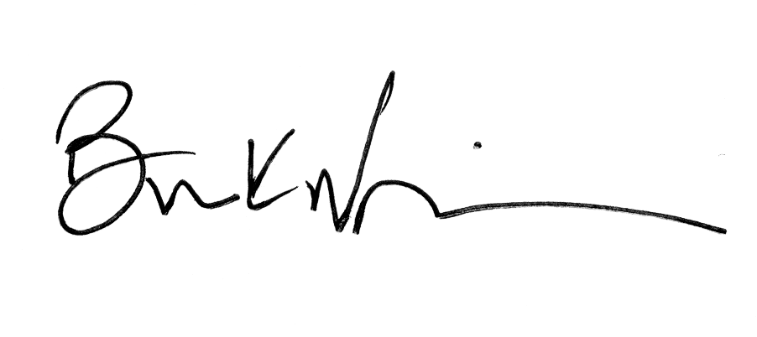

Brian K. Wiggins
SPE Sections Manager

Americas Office
222 Palisades Creek Drive, Richardson, Texas 75080-2040 U.S.A. • Fax: +1.9o72.952.9435 • E-mail: spedal@spe.org

