SPONSORSHIP OPPORTUNITIES for 2017-18 PROGRAM YEAR

SPE-GCS “Insert Group Name” Study Group (or Committee)

Mission and Objectives

The Society of Petroleum Engineers (SPE) is one of the largest individual member societies with more than 164,000 members in 143 countries. It’s Gulf Coast Section (SPE-GCS) has about 15,000 members in the 29 county area surrounding Houston.

The objectives of the SPE-GCS “Insert Group Name” Study Group (or Committee)

“Insert group’s mission statement.”

Benefits of sponsorship

Sponsoring the SPE-GCS “Insert Group Name” Study Group’s (or Committee’s) activities will bring increased visibility to your organization as a Leader among the oil & gas community and goodwill from stakeholders. Sponsorship opportunities include advertising your company logo on the SPE-GCS “Insert Group Name” Study Group’s (or Committee’s) website and SPE-GCS Connect monthly newsletter, posting banners and promotional materials at group events, hosting meeting lunches and door prizes, and promote the group’s activities in general... all at an affordable cost.

Our events are only possible thanks to the kind financial support from companies like yours; and I would like to thank you in advance for your participation and support. For more information about the SPE-GCS “Insert Group Name” Study Group (or Committee) and our upcoming events, please visit our SPE-GCS website at:
https://www.spegcs.org/study-groups/safety-environment/. (Update hyperlink with your SPE-GCS website page)

Platinum Sponsor
Special Annual Event
$6,000
Bronze Sponsor
Luncheon / Networking Event $500
Silver Sponsor
Special Annual Event
$2,000
Gold Sponsor
Special Annual Event
$4,000

In addition to improving visibility among the professionals in the oil and gas industry, event sponsors are also entitled to the following benefits.

Benefit / Sponsorship Level | Platinum  Special Annual Event  $6,000 | Gold  Special Annual Event  $4,000 | Silver  Special Annual  Event  $2,000 | Bronze  Luncheon / Networking  Event  $500
Logo on SPE-GCS event webpage | ✓ | ✓ | ✓ | ✓
Logo on SPE-GCS Connect Newsletter Event Listing | ✓ | ✓ | ✓ | ✓
Advertisement in Program Book for Event | Full Page | Half Page | Logo for all sponsors | Logo for all sponsors
Logo on Sponsorship Banner/Poster during Event | ✓ | ✓ | ✓
Logo on Pre-Event Slide Show | ✓ | ✓ | ✓
Complimentary Registration to Event | 3 | 2 | 1
Exclusive Recognition During Monthly Luncheon / Networking Events | 3 events | 2 events | 1 event
Promotional items with Sponsor’s Logo for Event | Provided by Sponsor | Provided by Sponsor
Special Company Flyer for Program Book for Event | Provided by Sponsor

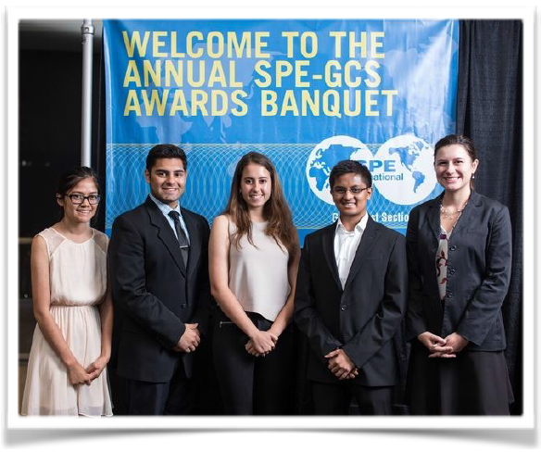
Where does the sponsorship money go?

The funds donated to SPE-GCS, a non‐profit organization, are used to sponsor high performing students in the Gulf Coast region during their college years. The funds aim to encourage and increase interest in the petroleum industry among graduating seniors and retain students currently enrolled in petroleum related academic disciplines. The funds also support programs in area primary and secondary schools to encourage students to develop their abilities in “STEM” - Science, Technology, Engineering and Mathematics.

