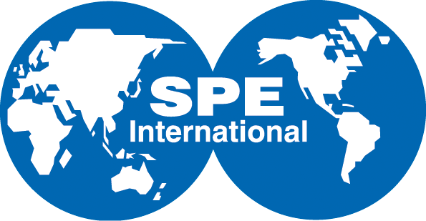
Houston
10777 Westheimer Road
Suite 1075
Houston, Texas 77042
713.779.9595 tel
713.779.4216 fax

Society of Petroleum Engineers Gulf Coast Section
Subject: Petroleum Engineering Scholarships

Here’s an opportunity for your company to help the Gulf Coast Section of the Society of Petroleum Engineers attract talented high school students to the petroleum engineering industry. You can be a sponsor of the Society of Petroleum Engineers - Gulf Coast Section (SPE-GCS) 2014-2015 Petroleum Engineering Scholarship Program. The funds your company provides will be used to grant scholarships to graduating high school seniors from the Houston area who are pursuing petroleum engineering related studies in college.

Sponsorships can be given in any monetary amount. Any sponsor who contributes $3,000 or more will have a named scholarship, but we welcome cash contributions as low as $100. All donors will be acknowledged in the SPE-GCS newsletter and highlighted in a presentation at our annual SPE-GCS awards banquet.

Thank you to all the individuals or companies that sponsored scholarships in the past: Anadarko, BHP Billiton, Chevron, Southwestern Energy, Champions Technologies, Devon Energy, Oxy, Schlumberger, and Shell. We hope that these same companies and more will sponsor scholarships for our recipients.

Checks can be made out to Society of Petroleum Engineers - Gulf Coast Section. Please reference the check to 2014 SPE Scholarship Sponsorship. Mail to the attention of Kathleen MacLennan at the SPE-GCS office at 10777 Westheimer Road, Suite 1075; Houston, Texas 77042. For tax purposes, The Society of Petroleum Engineers (SPE), Inc. is a 501 (c) (3) nonprofit educational organization with a tax number of 75-2001539.

If you have any questions please feel free to contact Tanhee Galindo by phone or email at 432-556-1932 or tanhee.galindo@catalystoilfield.com.

Thank you in advance for your support,


Tanhee Galindo
SPE-GCS Scholarship Committee Chair

